The Eden Project

Cultural Programmes - Proposal Form

In order to open our incredible resources to artists, performers, musicians, experiential developers and curators and to facilitate the incubation of projects, experiences and exhibitions that engage with topics of social or environmental relevance, we welcome proposals to be part of our cultural programme.

**Eden Mission**

We demonstrate and inspire positive action for the planet.

**Cultural Programming Statement**

The Eden Project celebrates the role cultural experiences can play in advocacy, and recognises the value of critical thinking and cross-disciplinary collaboration. We believe that art and cultural experiences have the power to challenged perceived wisdom, to provoke, captivate and inspire.

We present extraordinary, thought-provoking and ambitious artistic programmes to inspire a better future for all, with the ambition to:

+  Create opportunities for artists, performers and creative practitioners to engage with topics of social-environmental importance.

+  Connect, communicate and collaborate with grass-roots, national and international partners to share expertise, resources and reach new audiences.

+  Reach and engage broad audiences on-site and beyond with compelling content, to impact and influence public perceptions.

To make an enquiry for an exhibition, performance or presenting any cultural content at The Eden Project, please complete the following application form, complete and return in digital format to: [art@edenproject.com](mailto:art@edenproject.com)

Due to limited resources and budgets, we generally only consider proposals that are funded. Please note that due to high interest in our programmes and limited resources we are not able to facilitate every proposal, and are unable to respond to all applicants. Your proposal will be evaluated by our cultural programming team and we will be in contact if you have been successful, or if we have further questions.

Kindest regards,  
The Eden Project team

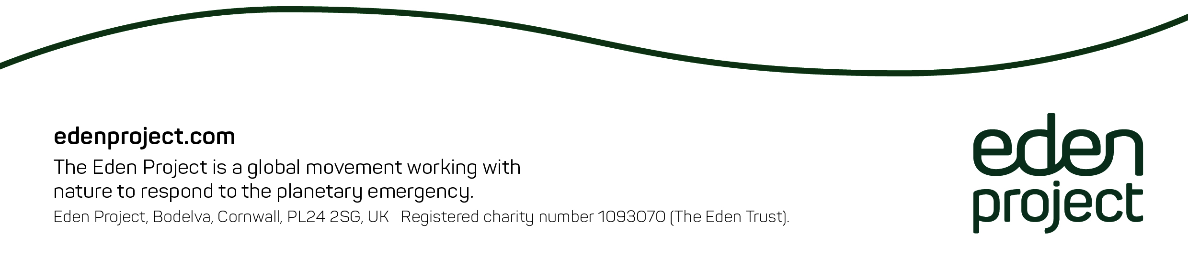

**Evaluation Considerations**

The quality of proposals received will be reviewed against the below criteria which is based on the Arts Council England, Core Quality Metrics:

+ Environmental sustainability – does it engage with themes of social and environmental importance. Will production methods or materials have a negative environmental impact?  
+ Public engagement – will the project resonate with visitors to the Eden Project, will it engage with public audiences beyond our site? Are there elements that are participatory or interactive?  
+ Concept: is it an interesting idea?  
+ Presentation: is it well presented, do we have confidence in production standards?  
+ Distinctiveness: is it different from things we have experienced before?  
+ Challenge: is it thought-provoking?  
+ Captivation: was it absorbing, will it hold our attention?  
+ Enthusiasm: would we be keen to see something like this again?  
+ Local impact: does it have local significance?  
+ Relevance: does it have something to say about the world in which we live today?  
+ Rigour: is it well thought through and put together?  
+ Financial viability: is the budget realistic and well thought through?  
+ Technical viability: do we have confidence in the technical viability of the project? Are there health and safety considerations?  
+ Management: does the applicant have the right experience, expertise and support to manage the project?  
+ Curatorial relevance: does the project align to our curatorial principles?  
+ Creative Case for Diversity: does the project support the creative case for diversity?  
+ Legacy: will the project have a long-lasting legacy. Will it be well documented? What is the long- term ambition of this project?

**Application Form**



|  |  |
| --- | --- |
| Your Details  We will need to process and store your personal data as part of considering your application, and will only do so in relation to this project. If you object to this processing, we will be unable to accept your application. For details of how we process and store your data please see our privacy policy at: www.edenproject.com/privacy-policy | |
| Full name/s and title/s | page3image3082436272 |
| Email | page3image3085593968 |
| Phone number | page3image3085605536 |
| Address | page3image3085611264page3image3085611968 |
| Organisation (if applicable) | page3image3085618256 |
| page3image3085618832 | |
| Project Details | |
| Project Title (if applicable) | page3image3085630048page3image3085632640 |
| Relevant Partners. Please attach a letter of support for any partners listed. |  |
| Curator/s / Creative Practitioners |  |
| Artist/s / Performers |  |
| Proposed length and preferred dates of activity. Are these dates flexible? | page3image3085650464page3image3085653056 |
| Outline of Intention (250 words max) |  |
| Overview of content (250 words max) | page3image3085665136 |
| Outline of resources requested (150 words max) |  |
| page3image3085667984page3image3085669792 | |
| Cultural Relevance | |
| Cultural Relevance to the Eden Project mission and cultural statement (250 words max) |  |
| page3image3085686672Public Engagement  (We welcome exhibitions that engage our public audiences) | |
| page3image3085698432  Would you or any contributors consider a workshop/talk/tour or other public activity as part of the exhibition or activity? |  |
| Title and outline of Public Engagement Activity (250 words max)  page3image3085717456 |  |
| Proposed Public Engagement Activity Dates |  |

|  |  |
| --- | --- |
| Resources  Please outline below any resources you request access to while at Eden. Please provide budget detail and whether you have funding secured or plan to make an application. **Please note that The Eden Project must not be referenced on third-party funding applications unless we have given prior consent in writing.** | |
| Eden resources required | page4image3078030608page4image3078098400 |
| Do you require gift in kind support from Eden? If so please provide details here plus total in-kind value. |  |
| Will you be requesting a letter of support from Eden? | page4image3072732608page4image3075771792 |
| Will the project require funding? Has this been secured? What is the total cost? And if funding has not yet been secured, what is your funding strategy?  Please attach a budget breakdown to this application |  |
| Please outline any further third-party gift-in-kind support already secured | page4image3079428224 |
| Please attach to this application any relevant third-party letters of support | page4image3080262272 |
|  | page4image3075824512page4image3075825152 |
| Marketing Assets  We will endeavour to promote your project across our digital platforms. To help us to do this please provide the content requested below with your application | |
| Please provide your social media handles here. If you decided to share content relevant to your residency please ensure you tag us appropriately so that we can share your content. Twitter @edenproject Instagram @edenprojectcornwall Facebook: @theedenproject | page4image3052170496 |
| Website address (if applicable) | page4image3082124288page4image3082108528 |
| Please attach up to 10 high resolution images (300 dpi minimum) Ensuring that you include:  + Profile Picture  + Images of previous work |  |
| Artist/Curator/ Creative Practioner Biography (250 words max) | page4image3076714704page4image3082615984 |